Enquiries Design
![Enquiries]
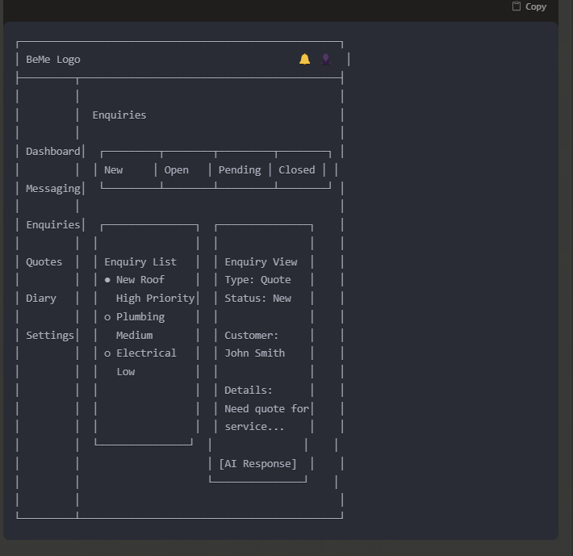

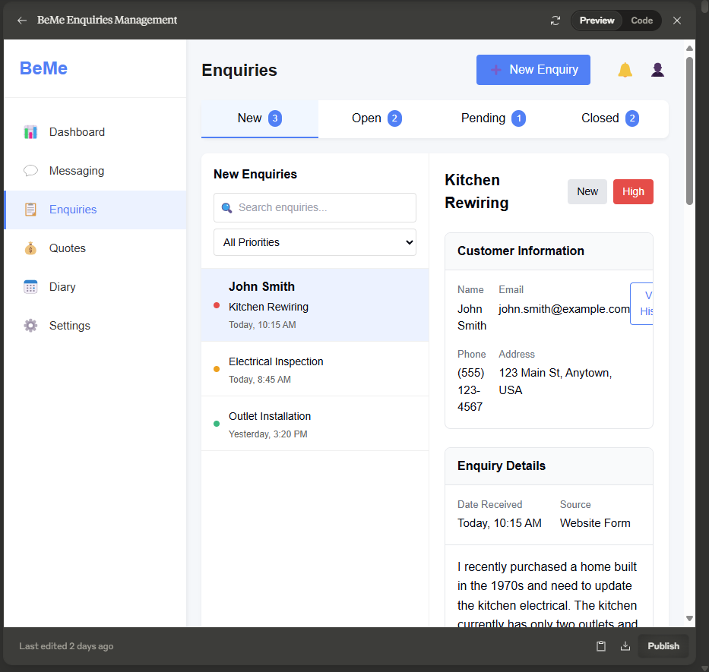
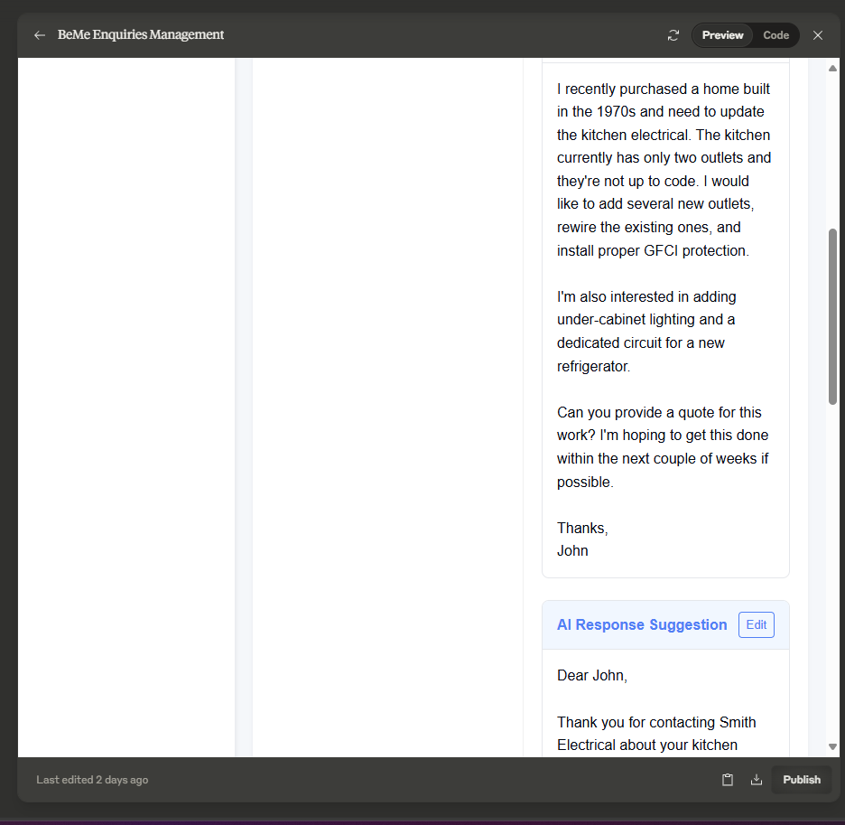
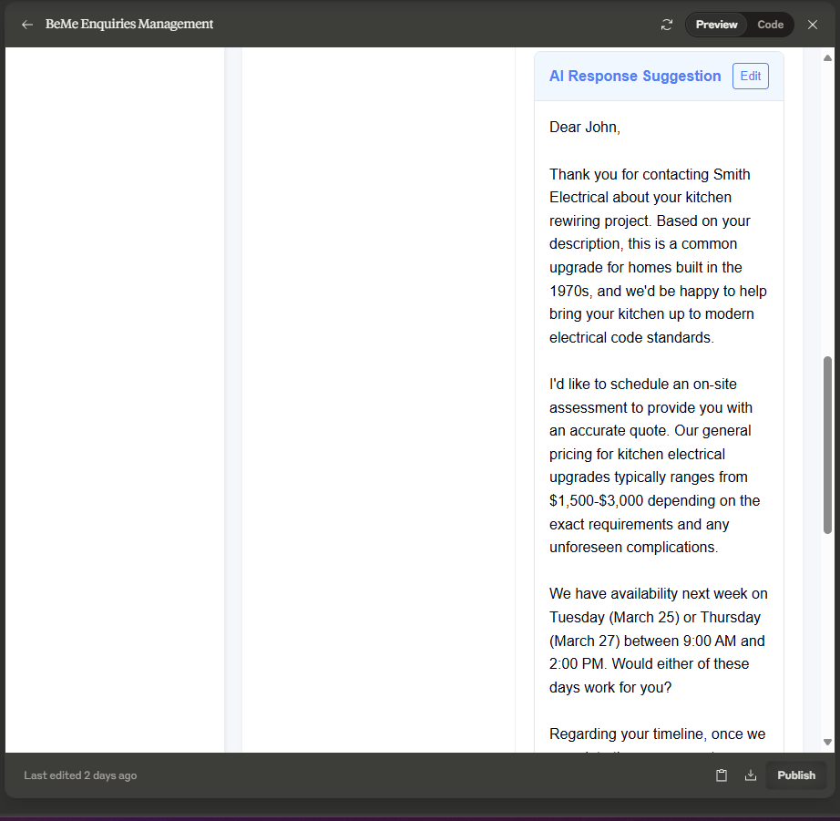
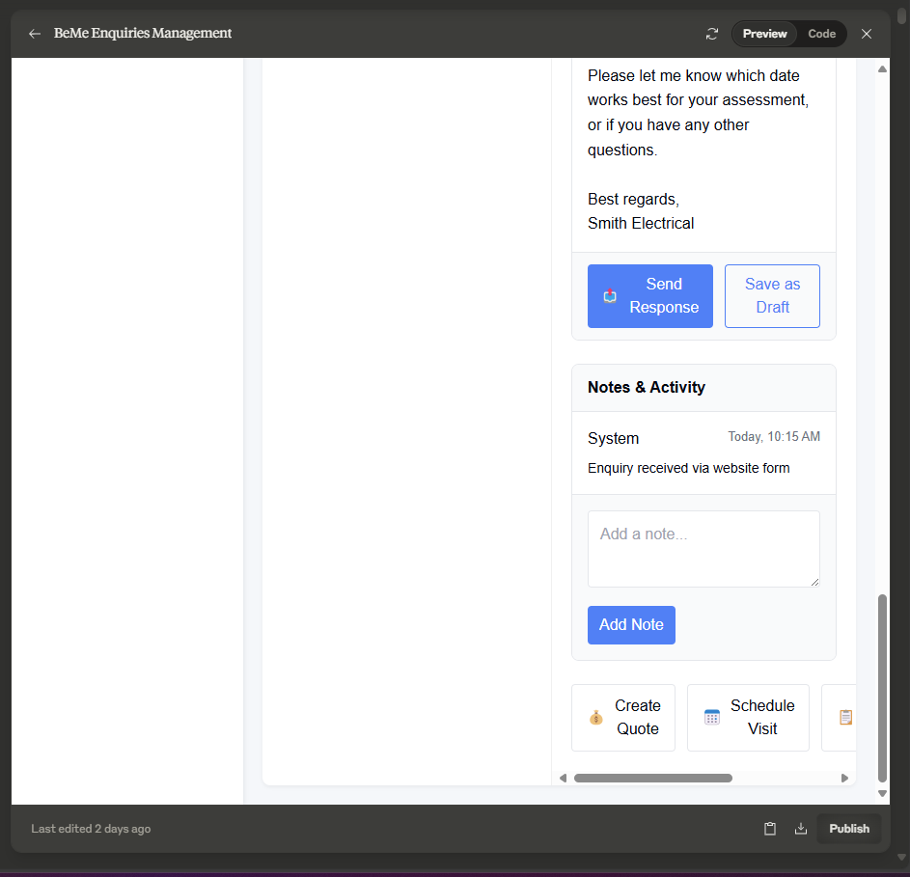

import React, { useState } from 'react';

const Enquiries = () => {
const [activeTab, setActiveTab] = useState('new');
const [selectedEnquiry, setSelectedEnquiry] = useState(1);

// Sample enquiries data
const enquiries = {
new: [
{ id: 1, customer: 'John Smith', subject: 'Kitchen Rewiring', date: 'Today, 10:15 AM', priority: 'high' },
{ id: 2, from: 'Sarah Williams', subject: 'Electrical Inspection', date: 'Today, 8:45 AM', priority: 'medium' },
{ id: 3, from: 'Mike Johnson', subject: 'Outlet Installation', date: 'Yesterday, 3:20 PM', priority: 'low' }
],
open: [
{ id: 4, customer: 'Emma Davis', subject: 'Lighting Installation', date: 'Mar 20, 2:30 PM', priority: 'medium' },
{ id: 5, customer: 'Robert Brown', subject: 'Panel Upgrade', date: 'Mar 19, 11:15 AM', priority: 'high' }
],
pending: [
{ id: 6, customer: 'Jennifer Lee', subject: 'Ceiling Fan Installation', date: 'Mar 18, 9:45 AM', priority: 'medium' }
],
closed: [
{ id: 7, customer: 'Michael Wilson', subject: 'Outlet Repair', date: 'Mar 15, 1:20 PM', priority: 'high' },
{ id: 8, customer: 'Lisa Taylor', subject: 'Landscape Lighting', date: 'Mar 12, 10:30 AM', priority: 'medium' }
]
};

// Current enquiry details
const currentEnquiry = {
id: 1,
customer: {
name: 'John Smith',
email: 'john.smith@example.com',
phone: '(555) 123-4567',
address: '123 Main St, Anytown, USA'
},
details: {
subject: 'Kitchen Rewiring',
date: 'Today, 10:15 AM',
status: 'New',
priority: 'High',
source: 'Website Form'
},
description: `I recently purchased a home built in the 1970s and need to update the kitchen electrical. The kitchen currently has only two outlets and they're not up to code. I would like to add several new outlets, rewire the existing ones, and install proper GFCI protection.

I'm also interested in adding under-cabinet lighting and a dedicated circuit for a new refrigerator.

Can you provide a quote for this work? I'm hoping to get this done within the next couple of weeks if possible.

Thanks,
John`,
notes: [
{ id: 101, author: 'System', date: 'Today, 10:15 AM', text: 'Enquiry received via website form' }
]
};

// AI response suggestion
const aiResponseSuggestion = `Dear John,

Thank you for contacting Smith Electrical about your kitchen rewiring project. Based on your description, this is a common upgrade for homes built in the 1970s, and we'd be happy to help bring your kitchen up to modern electrical code standards.

I'd like to schedule an on-site assessment to provide you with an accurate quote. Our general pricing for kitchen electrical upgrades typically ranges from $1,500-$3,000 depending on the exact requirements and any unforeseen complications.

We have availability next week on Tuesday (March 25) or Thursday (March 27) between 9:00 AM and 2:00 PM. Would either of these days work for you?

Regarding your timeline, once we complete the assessment, we can typically schedule the work within 7-10 days.

Please let me know which date works best for your assessment, or if you have any other questions.

Best regards,
Smith Electrical`;

return (
<div className="app-container">
{/* Sidebar */}
<div className="sidebar">
<div className="logo-container">
<div className="logo">BeMe</div>
</div>
<div className="sidebar-menu">
<div className="menu-item">
<div className="menu-icon">📊</div>
<div className="menu-text">Dashboard</div>
</div>
<div className="menu-item">
<div className="menu-icon">💬</div>
<div className="menu-text">Messaging</div>
</div>
<div className="menu-item active">
<div className="menu-icon">📋</div>
<div className="menu-text">Enquiries</div>
</div>
<div className="menu-item">
<div className="menu-icon">💰</div>
<div className="menu-text">Quotes</div>
</div>
<div className="menu-item">
<div className="menu-icon">📅</div>
<div className="menu-text">Diary</div>
</div>
<div className="menu-item">
<div className="menu-icon">⚙️</div>
<div className="menu-text">Settings</div>
</div>
</div>
</div>

{/* Main Content */}
<div className="main-content">
{/* Header */}
<div className="header">
<div className="page-title">Enquiries</div>
<div className="header-actions">
<button className="new-enquiry-btn">
<span className="new-icon">➕</span>
<span>New Enquiry</span>
</button>
<div className="notification-icon">🔔</div>
<div className="user-profile">👤</div>
</div>
</div>

{/* Enquiries Tabs */}
<div className="enquiries-tabs">
<div
className={`tab ${activeTab === 'new' ? 'active' : ''}`}
onClick={() => setActiveTab('new')}
>
<span className="tab-text">New</span>
<span className="tab-badge">{enquiries.new.length}</span>
</div>
<div
className={`tab ${activeTab === 'open' ? 'active' : ''}`}
onClick={() => setActiveTab('open')}
>
<span className="tab-text">Open</span>
<span className="tab-badge">{enquiries.open.length}</span>
</div>
<div
className={`tab ${activeTab === 'pending' ? 'active' : ''}`}
onClick={() => setActiveTab('pending')}
>
<span className="tab-text">Pending</span>
<span className="tab-badge">{enquiries.pending.length}</span>
</div>
<div
className={`tab ${activeTab === 'closed' ? 'active' : ''}`}
onClick={() => setActiveTab('closed')}
>
<span className="tab-text">Closed</span>
<span className="tab-badge">{enquiries.closed.length}</span>
</div>
</div>

{/* Enquiries Interface */}
<div className="enquiries-interface">
{/* Enquiry List */}
<div className="enquiry-list">
<div className="list-header">
<div className="list-title">{activeTab.charAt(0).toUpperCase() + activeTab.slice(1)} Enquiries</div>
<div className="list-actions">
<div className="search-box">
<input type="text" placeholder="Search enquiries..." />
<span className="search-icon">🔍</span>
</div>
<select className="filter-dropdown">
<option>All Priorities</option>
<option>High</option>
<option>Medium</option>
<option>Low</option>
</select>
</div>
</div>
<div className="enquiries">
{enquiries[activeTab].map(enquiry => (
<div
key={enquiry.id}
className={`enquiry-item ${enquiry.priority} ${selectedEnquiry === enquiry.id ? 'selected' : ''}`}
onClick={() => setSelectedEnquiry(enquiry.id)}
>
<div className="enquiry-priority">
<div className="priority-indicator"></div>
</div>
<div className="enquiry-content">
<div className="enquiry-customer">{enquiry.customer}</div>
<div className="enquiry-subject">{enquiry.subject}</div>
<div className="enquiry-date">{enquiry.date}</div>
</div>
</div>
))}
</div>
</div>

{/* Enquiry Details */}
<div className="enquiry-details">
{selectedEnquiry && (
<>
<div className="details-header">
<h2>{currentEnquiry.details.subject}</h2>
<div className="status-container">
<div className="status-badge">{currentEnquiry.details.status}</div>
<div className={`priority-badge ${currentEnquiry.details.priority.toLowerCase()}`}>
{currentEnquiry.details.priority}
</div>
</div>
</div>

<div className="details-content">
{/* Customer Information */}
<div className="detail-section">
<h3>Customer Information</h3>
<div className="customer-card">
<div className="customer-info">
<div className="info-group">
<div className="info-label">Name</div>
<div className="info-value">{currentEnquiry.customer.name}</div>
</div>
<div className="info-group">
<div className="info-label">Email</div>
<div className="info-value">{currentEnquiry.customer.email}</div>
</div>
<div className="info-group">
<div className="info-label">Phone</div>
<div className="info-value">{currentEnquiry.customer.phone}</div>
</div>
<div className="info-group">
<div className="info-label">Address</div>
<div className="info-value">{currentEnquiry.customer.address}</div>
</div>
</div>
<div className="customer-actions">
<button className="customer-action-btn">View History</button>
</div>
</div>
</div>

{/* Enquiry Details */}
<div className="detail-section">
<h3>Enquiry Details</h3>
<div className="enquiry-meta">
<div className="meta-group">
<div className="meta-label">Date Received</div>
<div className="meta-value">{currentEnquiry.details.date}</div>
</div>
<div className="meta-group">
<div className="meta-label">Source</div>
<div className="meta-value">{currentEnquiry.details.source}</div>
</div>
</div>
<div className="enquiry-description">
<pre>{currentEnquiry.description}</pre>
</div>
</div>

{/* AI Response */}
<div className="detail-section">
<div className="ai-response-header">
<h3>AI Response Suggestion</h3>
<button className="edit-btn">Edit</button>
</div>
<div className="ai-response-content">
<pre>{aiResponseSuggestion}</pre>
</div>
<div className="response-actions">
<button className="send-btn">
<span className="send-icon">📤</span>
<span>Send Response</span>
</button>
<button className="save-btn">Save as Draft</button>
</div>
</div>

{/* Notes and Activity */}
<div className="detail-section">
<h3>Notes & Activity</h3>
<div className="notes-list">
{currentEnquiry.notes.map(note => (
<div key={note.id} className="note-item">
<div className="note-header">
<div className="note-author">{note.author}</div>
<div className="note-date">{note.date}</div>
</div>
<div className="note-text">{note.text}</div>
</div>
))}
</div>
<div className="add-note">
<textarea placeholder="Add a note..."></textarea>
<button className="add-note-btn">Add Note</button>
</div>
</div>
</div>

<div className="details-actions">
<button className="action-btn">
<span className="action-icon">💰</span>
<span>Create Quote</span>
</button>
<button className="action-btn">
<span className="action-icon">📅</span>
<span>Schedule Visit</span>
</button>
<button className="action-btn">
<span className="action-icon">📋</span>
<span>Change Status</span>
</button>
<button className="action-btn">
<span className="action-icon">🔄</span>
<span>Update Priority</span>
</button>
</div>
</>
)}
</div>
</div>
</div>

<style jsx>{`
.app-container {
display: flex;
min-height: 100vh;
font-family: 'Inter', sans-serif;
background-color: #f5f7fa;
}

/* Sidebar styles */
.sidebar {
width: 240px;
background-color: white;
box-shadow: 2px 0 4px rgba(0, 0, 0, 0.05);
padding: 20px 0;
display: flex;
flex-direction: column;
}

.logo-container {
padding: 0 20px 20px;
border-bottom: 1px solid #f0f0f0;
margin-bottom: 20px;
}

.logo {
font-size: 24px;
font-weight: bold;
color: #3B82F6;
}

.sidebar-menu {
display: flex;
flex-direction: column;
flex-grow: 1;
}

.menu-item {
display: flex;
align-items: center;
padding: 12px 20px;
cursor: pointer;
transition: background-color 0.2s;
border-left: 3px solid transparent;
}

.menu-item:hover {
background-color: #f5f7fa;
}

.menu-item.active {
background-color: #ebf2ff;
border-left-color: #3B82F6;
}

.menu-icon {
margin-right: 12px;
font-size: 18px;
}

.menu-text {
font-size: 15px;
color: #333;
}

.menu-item.active .menu-text {
font-weight: 500;
color: #3B82F6;
}

/* Main content styles */
.main-content {
flex: 1;
padding: 20px;
overflow-y: auto;
display: flex;
flex-direction: column;
}

.header {
display: flex;
justify-content: space-between;
align-items: center;
margin-bottom: 20px;
}

.page-title {
font-size: 22px;
font-weight: 600;
color: #1a1a1a;
}

.header-actions {
display: flex;
align-items: center;
}

.new-enquiry-btn {
display: flex;
align-items: center;
background-color: #3B82F6;
color: white;
border: none;
border-radius: 4px;
padding: 8px 16px;
margin-right: 16px;
cursor: pointer;
font-weight: 500;
transition: background-color 0.2s;
}

.new-enquiry-btn:hover {
background-color: #2563eb;
}

.new-icon {
margin-right: 8px;
font-size: 14px;
}

.notification-icon, .user-profile {
font-size: 20px;
margin-left: 16px;
cursor: pointer;
}

/* Enquiries tabs */
.enquiries-tabs {
display: flex;
background-color: white;
border-radius: 8px;
margin-bottom: 20px;
box-shadow: 0 2px 4px rgba(0, 0, 0, 0.05);
}

.tab {
display: flex;
align-items: center;
padding: 12px 20px;
cursor: pointer;
border-bottom: 2px solid transparent;
flex: 1;
justify-content: center;
}

.tab:hover {
background-color: #f8faff;
}

.tab.active {
border-bottom-color: #3B82F6;
background-color: #f0f7ff;
}

.tab-text {
font-weight: 500;
}

.tab-badge {
background-color: #3B82F6;
color: white;
font-size: 12px;
padding: 2px 6px;
border-radius: 10px;
margin-left: 8px;
}

/* Enquiries interface */
.enquiries-interface {
display: flex;
flex: 1;
background-color: white;
border-radius: 8px;
box-shadow: 0 2px 4px rgba(0, 0, 0, 0.05);
overflow: hidden;
}

/* Enquiry list */
.enquiry-list {
width: 300px;
border-right: 1px solid #f0f0f0;
display: flex;
flex-direction: column;
}

.list-header {
padding: 16px;
border-bottom: 1px solid #f0f0f0;
}

.list-title {
font-size: 16px;
font-weight: 600;
margin-bottom: 12px;
}

.list-actions {
display: flex;
flex-direction: column;
gap: 8px;
}

.search-box {
position: relative;
}

.search-box input {
width: 100%;
padding: 8px 8px 8px 32px;
border: 1px solid #e0e0e0;
border-radius: 4px;
font-size: 14px;
}

.search-icon {
position: absolute;
left: 8px;
top: 50%;
transform: translateY(-50%);
font-size: 14px;
}

.filter-dropdown {
padding: 8px;
border: 1px solid #e0e0e0;
border-radius: 4px;
font-size: 14px;
width: 100%;
}

.enquiries {
flex: 1;
overflow-y: auto;
}

.enquiry-item {
display: flex;
padding: 12px 16px;
border-bottom: 1px solid #f0f0f0;
cursor: pointer;
transition: background-color 0.2s;
}

.enquiry-item:hover {
background-color: #f8faff;
}

.enquiry-item.selected {
background-color: #ebf2ff;
}

.enquiry-priority {
margin-right: 12px;
display: flex;
align-items: center;
}

.priority-indicator {
width: 8px;
height: 8px;
border-radius: 50%;
background-color: #9ca3af;
}

.enquiry-item.high .priority-indicator {
background-color: #ef4444;
}

.enquiry-item.medium .priority-indicator {
background-color: #f59e0b;
}

.enquiry-item.low .priority-indicator {
background-color: #10b981;
}

.enquiry-content {
flex: 1;
}

.enquiry-customer {
font-weight: 600;
margin-bottom: 4px;
}

.enquiry-subject {
font-size: 14px;
margin-bottom: 4px;
}

.enquiry-date {
font-size: 12px;
color: #666;
}

/* Enquiry details */
.enquiry-details {
flex: 1;
padding: 20px;
overflow-y: auto;
}

.details-header {
display: flex;
justify-content: space-between;
align-items: center;
margin-bottom: 24px;
}

.details-header h2 {
font-size: 20px;
font-weight: 600;
margin: 0;
}

.status-container {
display: flex;
align-items: center;
gap: 8px;
}

.status-badge {
background-color: #e5e7eb;
padding: 6px 12px;
border-radius: 4px;
font-size: 14px;
font-weight: 500;
}

.priority-badge {
padding: 6px 12px;
border-radius: 4px;
font-size: 14px;
font-weight: 500;
color: white;
}

.priority-badge.high {
background-color: #ef4444;
}

.priority-badge.medium {
background-color: #f59e0b;
}

.priority-badge.low {
background-color: #10b981;
}

.details-content {
display: flex;
flex-direction: column;
gap: 24px;
}

.detail-section {
border: 1px solid #e5e7eb;
border-radius: 8px;
overflow: hidden;
}

.detail-section h3 {
font-size: 16px;
font-weight: 600;
margin: 0;
padding: 12px 16px;
background-color: #f9fafb;
border-bottom: 1px solid #e5e7eb;
}

.customer-card {
padding: 16px;
display: flex;
justify-content: space-between;
}

.customer-info {
display: grid;
grid-template-columns: repeat(2, 1fr);
gap: 16px;
flex: 1;
}

.info-group {
display: flex;
flex-direction: column;
}

.info-label {
font-size: 13px;
color: #6b7280;
margin-bottom: 4px;
}

.info-value {
font-size: 15px;
font-weight: 500;
}

.customer-actions {
display: flex;
align-items: flex-start;
}

.customer-action-btn {
background-color: transparent;
color: #3B82F6;
border: 1px solid #3B82F6;
padding: 6px 12px;
border-radius: 4px;
font-size: 14px;
cursor: pointer;
transition: all 0.2s;
}

.customer-action-btn:hover {
background-color: #ebf2ff;
}

.enquiry-meta {
display: flex;
padding: 16px;
gap: 24px;
border-bottom: 1px solid #e5e7eb;
}

.meta-group {
display: flex;
flex-direction: column;
}

.meta-label {
font-size: 13px;
color: #6b7280;
margin-bottom: 4px;
}

.meta-value {
font-size: 15px;
font-weight: 500;
}

.enquiry-description {
padding: 16px;
}

.enquiry-description pre {
font-family: 'Inter', sans-serif;
white-space: pre-wrap;
margin: 0;
line-height: 1.6;
}

.ai-response-header {
display: flex;
justify-content: space-between;
align-items: center;
padding: 12px 16px;
background-color: #f0f7ff;
border-bottom: 1px solid #e5e7eb;
}

.ai-response-header h3 {
background-color: transparent;
padding: 0;
border: none;
color: #3B82F6;
}

.edit-btn {
background-color: transparent;
border: 1px solid #3B82F6;
color: #3B82F6;
border-radius: 4px;
padding: 4px 8px;
font-size: 13px;
cursor: pointer;
transition: all 0.2s;
}

.edit-btn:hover {
background-color: #ebf2ff;
}

.ai-response-content {
padding: 16px;
}

.ai-response-content pre {
font-family: 'Inter', sans-serif;
white-space: pre-wrap;
margin: 0;
line-height: 1.6;
}

.response-actions {
display: flex;
padding: 12px 16px;
gap: 12px;
border-top: 1px solid #e5e7eb;
background-color: #f9fafb;
}

.send-btn {
display: flex;
align-items: center;
background-color: #3B82F6;
color: white;
border: none;
border-radius: 4px;
padding: 8px 12px;
font-weight: 500;
cursor: pointer;
transition: background-color 0.2s;
}

.send-btn:hover {
background-color: #2563eb;
}

.send-icon {
margin-right: 6px;
}

.save-btn {
background-color: transparent;
border: 1px solid #3B82F6;
color: #3B82F6;
border-radius: 4px;
padding: 8px 12px;
font-weight: 500;
cursor: pointer;
transition: all 0.2s;
}

.save-btn:hover {
background-color: #ebf2ff;
}

.notes-list {
padding: 16px;
}

.note-item {
border-bottom: 1px solid #e5e7eb;
padding-bottom: 12px;
margin-bottom: 12px;
}

.note-item:last-child {
border-bottom: none;
margin-bottom: 0;
padding-bottom: 0;
}

.note-header {
display: flex;
justify-content: space-between;
margin-bottom: 8px;
}

.note-author {
font-weight: 500;
}

.note-date {
font-size: 13px;
color: #6b7280;
}

.note-text {
font-size: 14px;
line-height: 1.5;
}

.add-note {
padding: 16px;
border-top: 1px solid #e5e7eb;
background-color: #f9fafb;
}

.add-note textarea {
width: 100%;
padding: 12px;
border: 1px solid #e5e7eb;
border-radius: 4px;
resize: vertical;
min-height: 80px;
margin-bottom: 12px;
font-family: 'Inter', sans-serif;
}

.add-note-btn {
background-color: #3B82F6;
color: white;
border: none;
border-radius: 4px;
padding: 8px 12px;
font-weight: 500;
cursor: pointer;
transition: background-color 0.2s;
}

.add-note-btn:hover {
background-color: #2563eb;
}

.details-actions {
display: flex;
gap: 12px;
margin-top: 24px;
}

.action-btn {
display: flex;
align-items: center;
background-color: white;
border: 1px solid #e5e7eb;
border-radius: 4px;
padding: 10px 14px;
font-weight: 500;
cursor: pointer;
transition: all 0.2s;
}

.action-btn:hover {
background-color: #f9fafb;
border-color: #d1d5db;
}

.action-icon {
margin-right: 8px;
}
`}</style>
</div>
);
};

export default Enquiries;

